Chapter # 4: Result & Analysis

Student : Ramman

Title: ERP System For Institutes

Contents

Chapter #4: Result & Analysis 4

Result of Python ERP 4

1. Home Page 4

2. Register User page 6

3.Login PAGE 6

4.User Profile Page: 8

5.Logged out to get home page again 9

6. MYSQL Database 9

7.Database Records 11

8.Python ERP Project 11

9.Python Code Review 12

10.Python Packages 12

11. Critical Analysis 13

11.1 Sentiment Analysis 13

11.2 Enhancing Automation using python code Injection 13

11.3 Big Data ERP IOT Projection 13

# Chapter #4: Result & Analysis

(Vogel, P., Klooster, T., Andrikopoulos, V. and Lungu, M., 2017) low effort analytics platform which analyze & visualize, web application are written in python flask programing since POSTGRE SQL database communications might be crashed sometimes alternative way to construct database with MYSQL server using Apache Xampp server technology. Flask is python web based framework in which ecosystem extension support developer application which are performed better comparative to previous web framework using Java, C#. flask library integrated with all web programming modules such as html, CSS & JavaScript, which perform better web experience fast, integrated reliable and achievable. (Mufid, M.R., Basofi, A., Al Rasyid, M.U.H. and Rochimansyah, I.F., 2019,) designing of model view controller which composed of CRUD operations, flask is micro web framework using the python language which is easy to understand and easy to implementation comparison to C++ and Java Programming, since if comparison with C# ASP.net python is better programing in all language platform.

## Result of Python ERP

## Home Page

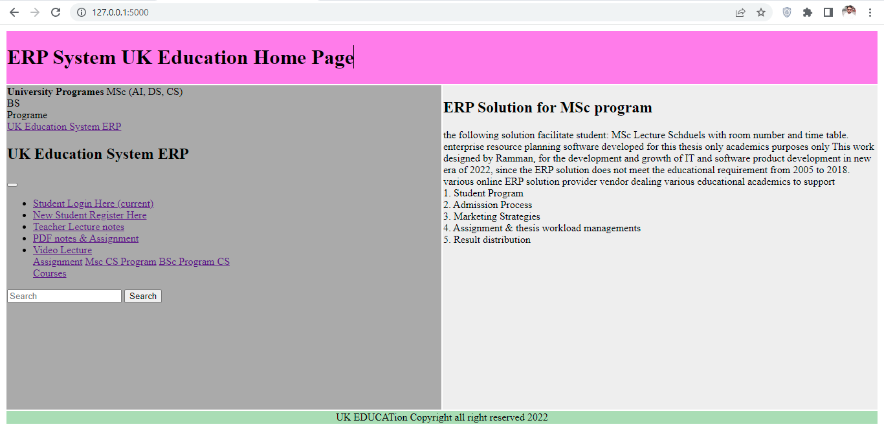

The objective of this Python flask application equipped with HTML & CSS bootstrap application, since bootstrap quickly used to create the html &CSS web pages quickly, its support to develop web application python bootstrap plugin is major component of this project, to implement project by using the bootstrap plugin including html & CSS layer. Bootstrap plugin easily installed in python Pycharm by implementing creative web sheet awesome font’s style and background color. Web page layout also created by the bootstrap system.

Bootstrap FONT, HTML & CSS Templates in Pycharm Community Edition:

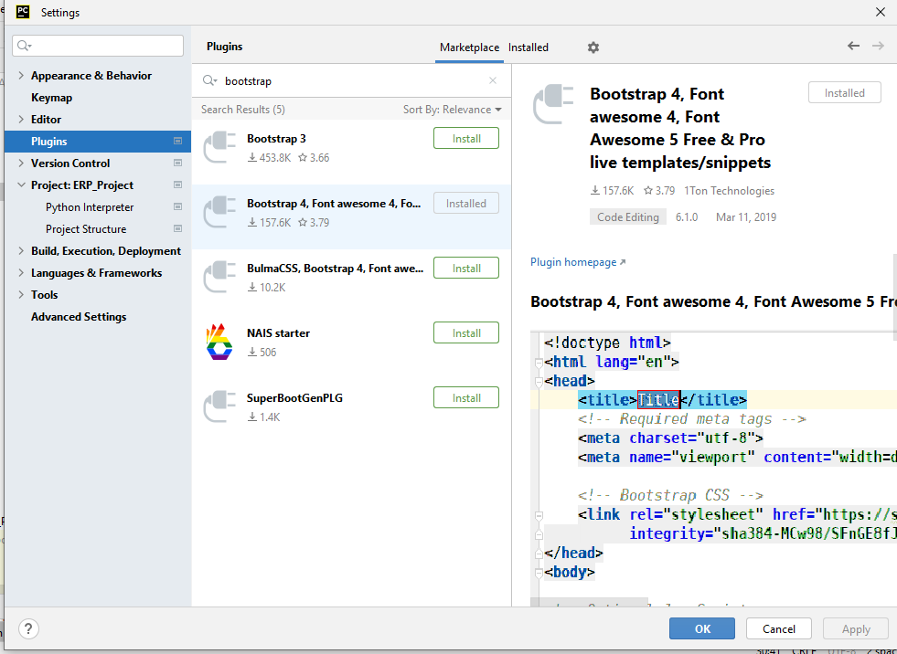

Since Pycharm community edition 2022.1.2 version contain various featured application with consecutives running applications suits, since the enterprise application composed with various planning of educational resources in which different educational resources has been involved. (Lokhande, P.S., Aslam, F., Hawa, N., Munir, J. and Gulamgaus, M., 2015.) Python programming is very efficient and intelligent way to design and implements python web based application using the flask framework, comparison with python DJANGO is not perform well, hence Django is complex to implement needs improvement and more research required to develop attractive web application. Web portal for student which support all desired requirement of student management system, the focus of this solution only based on MSc computer program which needs assignment, lecture notes, video and class schedules. The good themes and styles of web which attract more students to take admission in universities on the following mentioned program. Since flask is only web framework of python which fulfill all the requirements of web portal.

The database connection with MYSQL is very easy comparison to POSTGRESQL database system, which needs more research to communicate with web application in more organized manner. MYSQL database system using the Xampp framework which are more powerful system, the database library of MySQL database installed in python flask application before deploying the database connection of web applications.

## Register User page

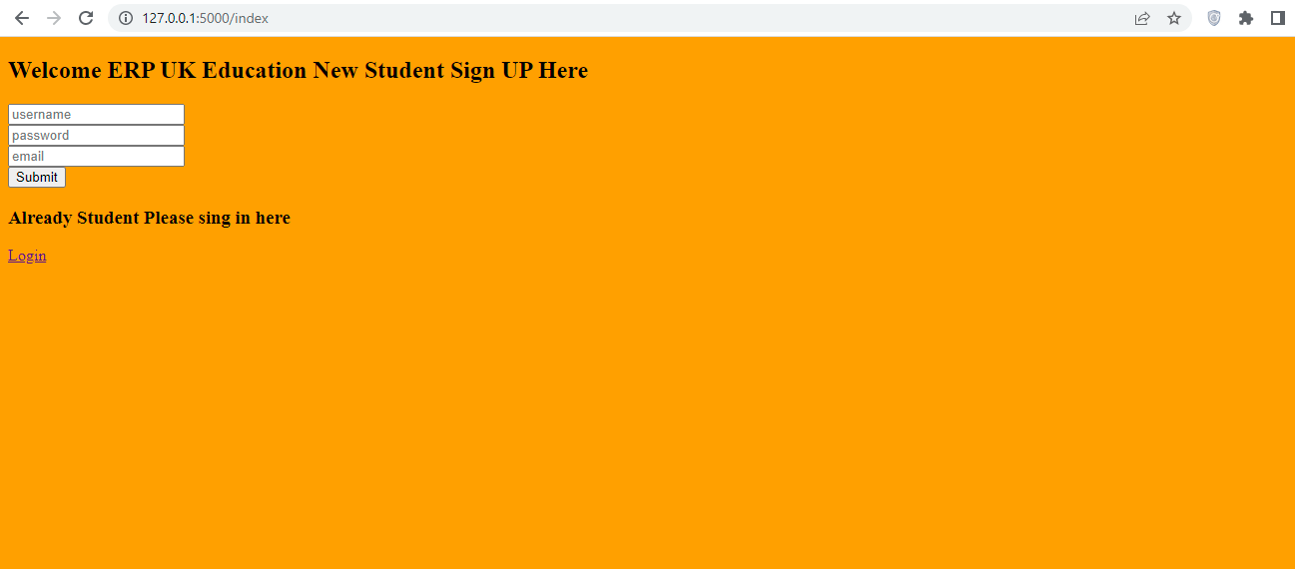

The flask and MYSQL database installing process as follows:

1. PIP install Flask MYSQLDB
2. Pip install MySQL-client
3. Pip install Flask

The following library should be installed in python Pycharm community edition version 2022. Register user page developed with HTML & CSS Bootstrap with backend database connectivity, user enter their credentials by username, password and email to register at the ERP portal. This ERP only designed for MSc Computer program student only. If the student already registered to the portal it would enter the username and password to get the home page of MSc.

## 3.Login PAGE

Login page design to manage the user profiles in which user can login their user profile to get the latest assignment & lecture notes. Login credential as should be followed the standard rules and regulations of the user management system such as username and password.

Email address of the user might be used for username and password criteria should be followed the password protection criteria to secure the login credentials. User management enable the administrator to see user email address and password credentials in database system.

Flask application for login page running in localhost port number 5000 on login page. The screenshot of running application has been taken as follows:

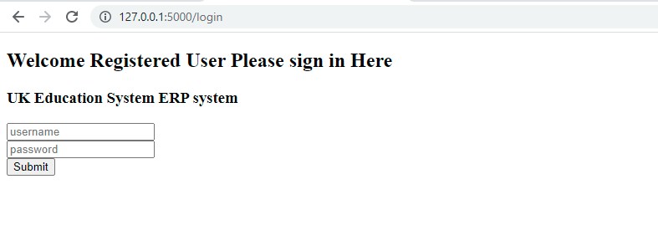

In login page student login to the portal to get the home page which all full of resource planning to support only student.

1. Student Logged in to view Home Page

Student logged to their user profile to see the lecture slides, lecture notes pdf and video lecture online. Student able to get the latest assignment output on the particular page. Lecture schedule is clearly visible to the user page to see the lecture room and timing in overall week.

The following listing on user profile as follows:

1. Video lecture
2. Lecture PDF Notes
3. Lecture Slides
4. Lecture Schedules Weekly
5. Assignment uploaded
6. Due date of assignment mentioned.
7. Faculty meeting time listing
8. Notification and announcement is mentioned on user profile.
9. User management all credential is listed in the user profile to complete the all enterprise resource planning outcome.

ERP python file which is main file of application to executes all html render templates. Signup page login page and home page which controls all enterprise resource planning outcome to label the student management system.

## 4.User Profile Page:

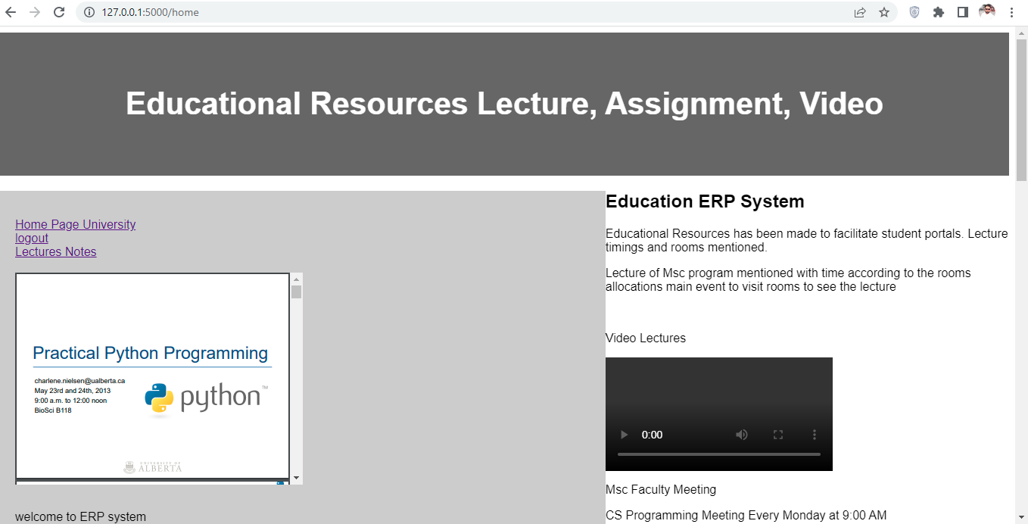 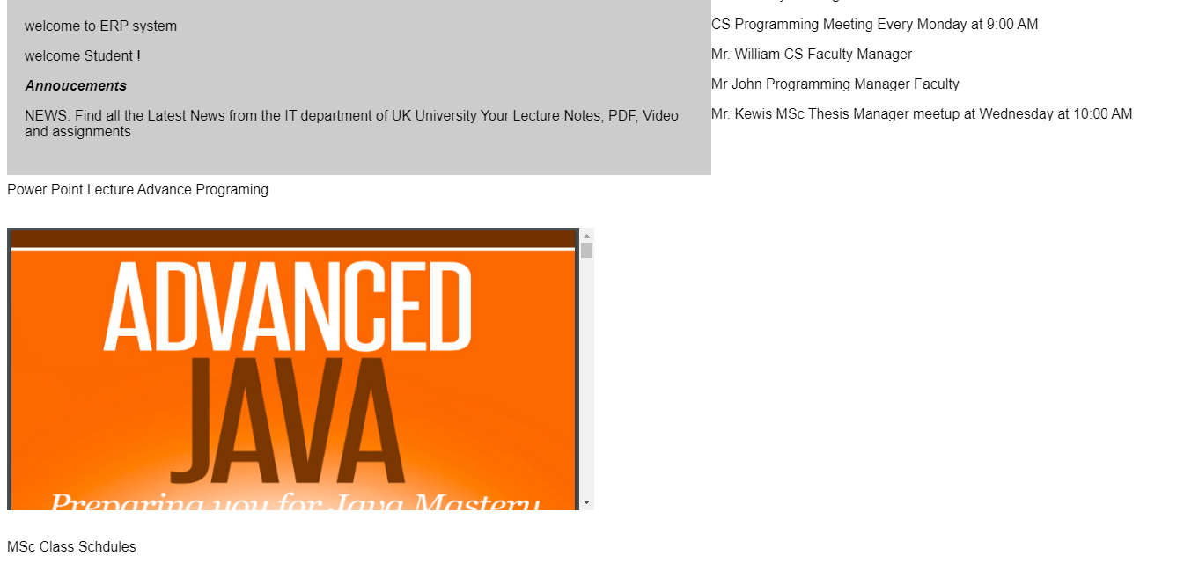

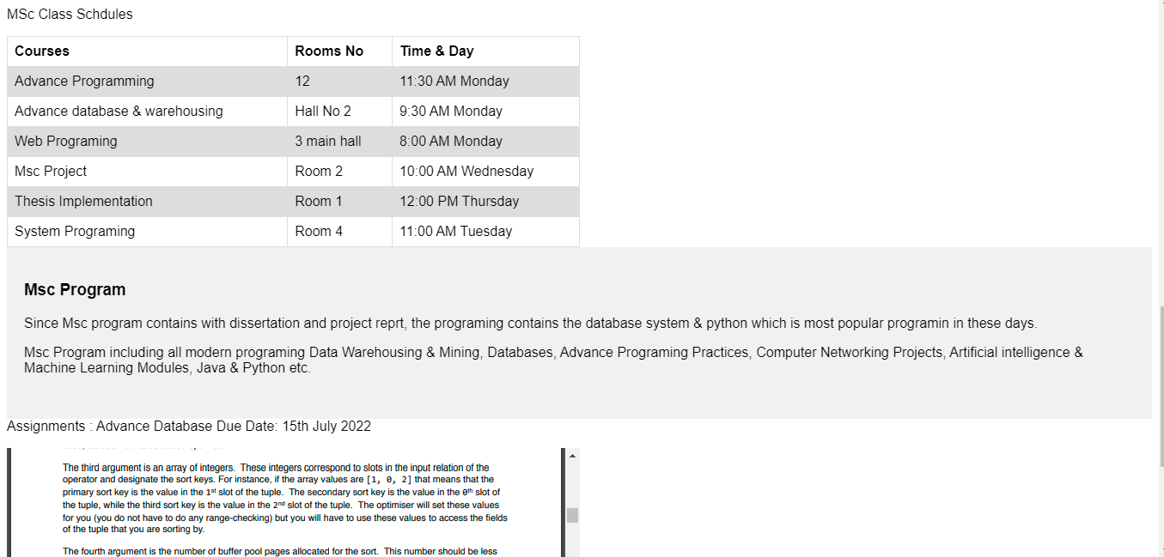

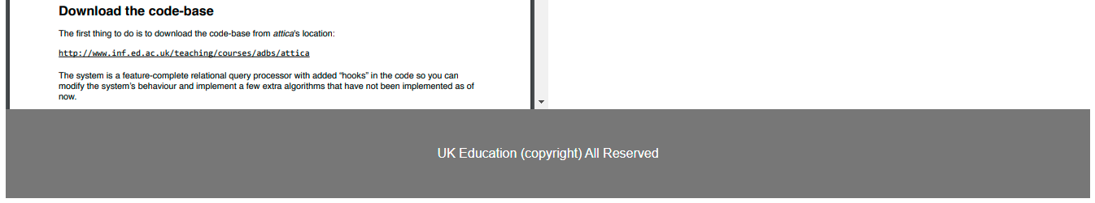

## 5.Logged out to get home page again

User log out to their profile it will redirect to the home page in which user can view all latest announcements of the university portal, the main page of enterprise resource planning enable them user to get all the credentials of user management.

Main page listed with the following content as follows:

1. Sign up here
2. Login page
3. General Announcement
4. Assignment Announcement

Comparative to active directory LDAP login, this login system is web based system which connected with backend on database system, in this login management no needs to add user group management all user treated as individual group of user which belongs to single class only.

Home page appear when user log out to their login session. Each user see the login profile of same MSc program credentials.

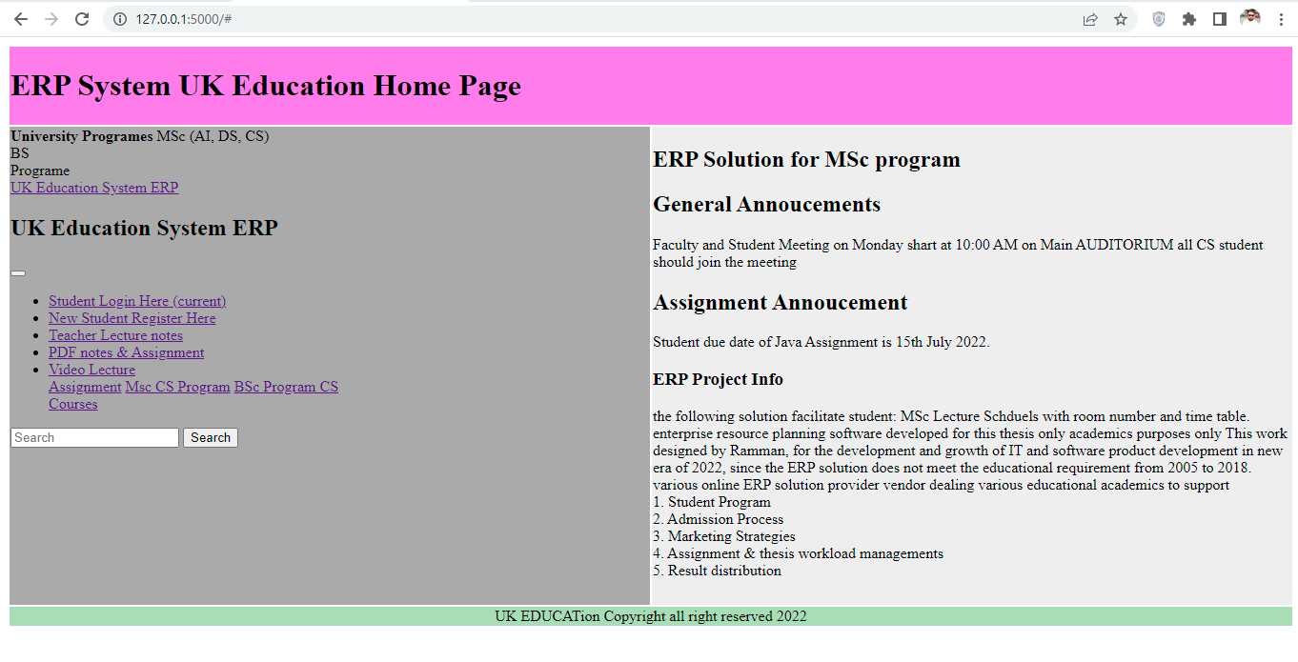

## 6. MYSQL Database

MySQL database is most commonly used database in the system which enhance the implementations of educational resources in the backend. (El Mohadab, M., Khalene, B.B. and Safi, S., 2017) integrated business process related to fee submission of student has been resolved by ERP system using the online system. Integrated intelligence areas such as workflow, management communication processes which organize to enhance the functional area. The reason to choose ERP software which delivers the competences, hence reason to choosing the common database which support all process management backend control and record keeping purposes. The objectives of database to executes financial query processing without delay, the common online ERP system paid license which does not fulfill the educational requirement. (Ahmed, F.Y., Sreejith, R. and Abdullah, M.I., 2021), enhancement of ecommerce database system using the PHP myadmin database system, the overall functionality of MySQL database system user friendly interface.

Database creation process carried out as follows:

1. Create new database 🡪 flaskdb
2. Create new table 🡪 users
3. Add attributes name and data type values in the table as clearly seen below:
4. Id: int length 11, name: varchar length 150, email: varchar length 150, password varchar length 150.
5. SQL query processing system works efficiently to process the database query.
6. Database import/export process which integrate to export the project to another location and computer.
7. Database running in localhost.
8. Browse the query to delete the recorded entry in the database system, recorded database delete when the information is not required.

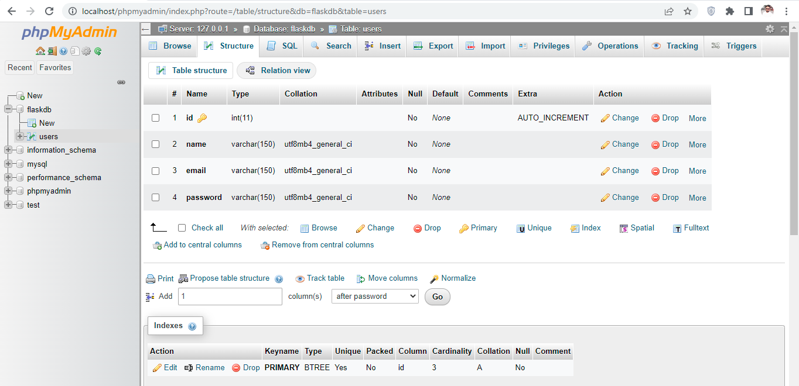

Database record which represent the user id name and email address followed by user password, which is necessary action to keep the user record to manage the enterprise resource planning system in the database system. The new record adding in the flaks website when user creating their new credential the necessary action has been taken to process the query in action to process the educational resources.

Database system enhance the visibility experience of python website to deploy the student friendly studies management system according to the UK standard requirement.

UK educational system manage by various online paid ERP system, e.g. Microsoft, Amazon, ORACLE etc. but still the requirement needs to modified according to the educational standard requirement, so needs to deploy the system again by implementing the customize system with python flaks micro web frameworks.

## 7.Database Records

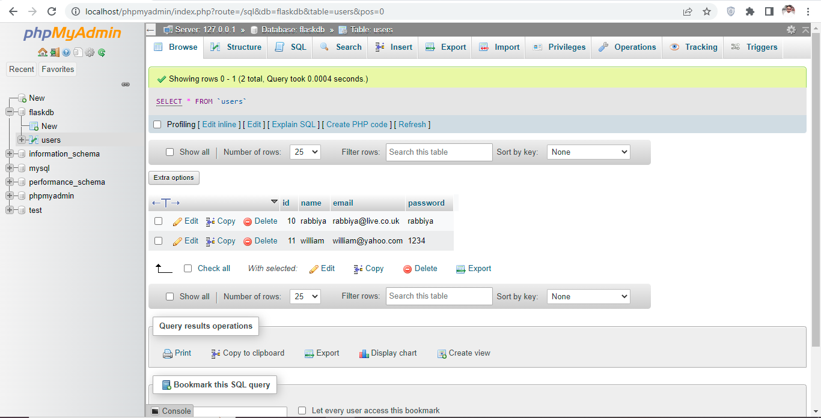

## 8.Python ERP Project

(De Carvalho, R.A. and Monnerat, R.M., 2008) deployed previous project in python programming hence this project is more efficient than previous one, implementing enterprise resource planning projection which capture the necessary information in order to process and reflect the code.

In this project the coding process admired by python main file which used to execute the app route files using the python main function. Render templates contain html & CSS files.

The following templates executes from the main route ERP files as follows:

1. Main HTML
2. Signup HTML
3. Home html
4. Login html
5. 404 html
6. Style css file

* In the login and registration process the post method implemented to process the query in the database system in MYSQL system.
* Python login and login check function implemented to verify the login credentials entered by user during the login process.
* Main app route file executed through render templates which contains html main file.
* CSS templates followed from the Google bootstrap sites. (bbbotrap 2021)
* HTML coding sequences followed from the bootstrap template (getbootstrap 2021)
* Python coding implemented by learning video lectures from YouTube video tutorial sites.
* Python implementation has been carried out to resumes all the functionality through the protocol layer of 5000 by running the flask app in the browser though local host.

## 9.Python Code Review

The following screen presented the python coding view.

1. ERP main python file
2. Render templates includes all HTML files contain the login, logout, home and main page.

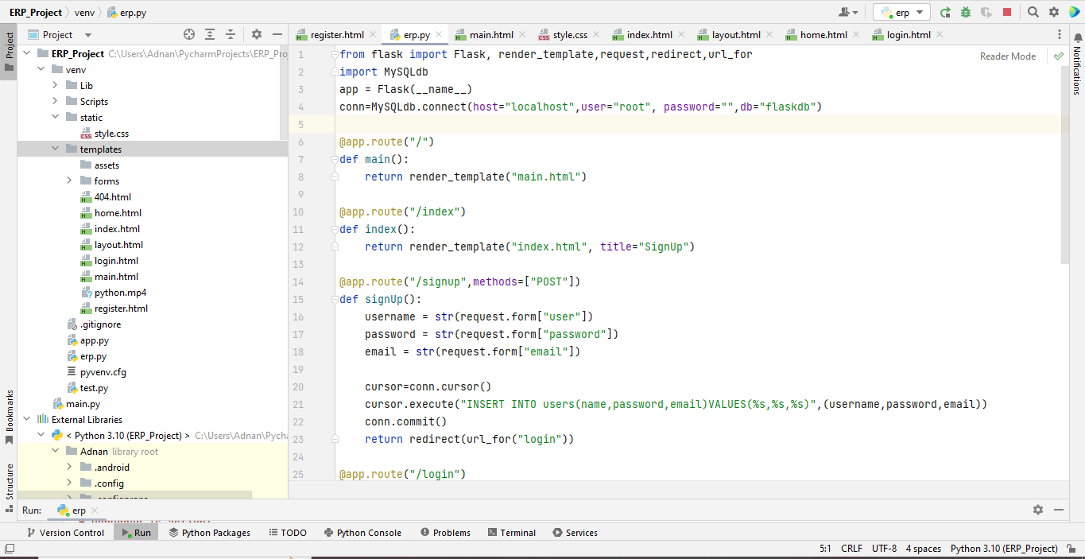

Python flaks is micro web frameworks to process the complex database operation in browser, since the database system implemented through the MySQL server.

## 10.Python Packages

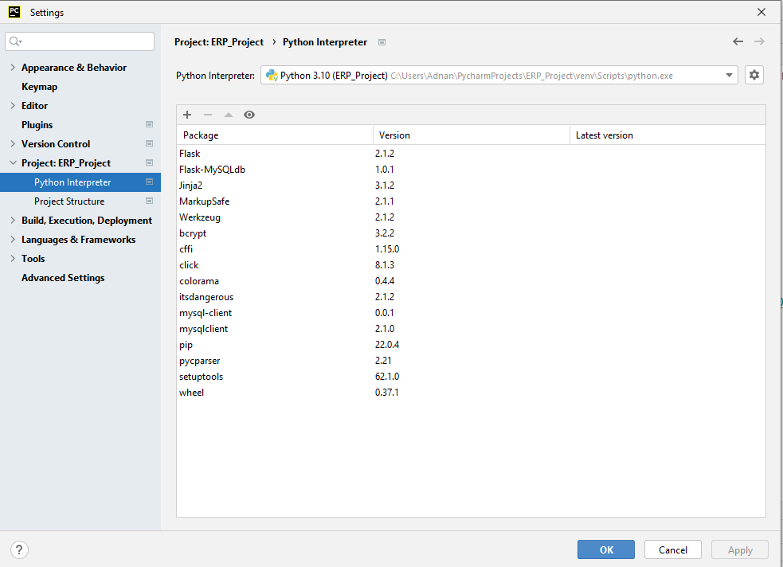

Python packages includes the python library needs to installed in the Pycharm community edition 2022 version to process all credential of ERP project.

## 11. Critical Analysis

(Mutongwa, M.S. and Rabah, K., 2013) ERP system solution proposed to process the small and medium task on web which facilitate the educational resources, hence ERP is integrated information system, the increasing demands of ERP system which integrated with various module, objectives of this research to develop ERP system to process small and medium enterprise industries, but comparison with education system needs to refurbished them. (Zhou, C., Zhou, T. and Bai, W., 2018,) key finding of this project to implements smartphone NFC technology using the ERP system hence the near field communication which is based on short range communication technology which combines the ERP data streams on the phone. This research using the cross platform third party tool to support android phone user which customized short range communication method to view ERP resources on their telephone screen. Since the security of short range is challenging to secure the end to end encryption.

## 11.1 Sentiment Analysis

This research proposed (Sarlan, A., Nadam, C. and Basri, S., 2014) twitter sentiment analysis based on machine learning method, twitter is most common social media platform backed process by enterprise resource planning system on regional based, result carried on python DJANGO framework to analyze the positive and negative feedbacks of customer on twitter database.

## 11.2 Enhancing Automation using python code Injection

(Novak, P., Douda, P., Vyskočil, J. and Wally, B., 2021) industrial 4 revolution corresponding to preproduction processes under production resource process. Automation process carried out using python script injection to represent needed information on the web which demonstrate industry 4 testbed.

## 11.3 Big Data ERP IOT Projection

(Sun, G., Huang, Z. and Yue, L., 2022) intelligent decision system process bit data analytics using ERP system and design the intelligence support system in automotive supply chain business. Python script test the ERP script which executes fast in less time compare to java, c# ASP, and python is much better than any other platform.